Holloway Game Jerseys (generally fits true to size)
ADULT sizes
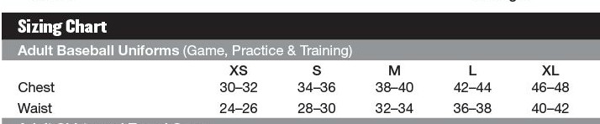

YOUTH sizes S M L XL
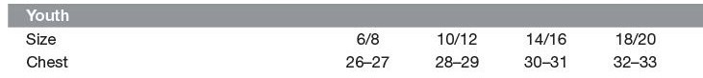
Richardson Hats
We will have FLEX/FIT 40pt hats. XS/S, S/M or L/XL

